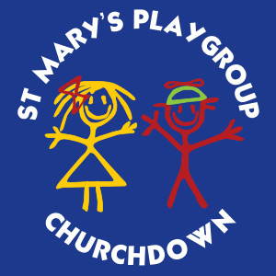
Application to Join St. Mary’s Playgroup

Full name of child ......................................................................................................
Date of birth ......................................................................................................
Name(s) of parent(s)......................................................................................................
Address .........................................................................................................................
.......................................................................................................................................
.......................................................................................................................................
Post code ................................ Telephone ....................................................................

Email: ............................................................................................................................
I wish to put my child’s name on a waiting list for a place at St. Mary’s Playgroup and enclose cash/cheque for £15 which is a non-refundable for a registration fee. Cheques made payable to St. Mary’s Playgroup.
When your child is 2 years 6 months old they will be offered a place as soon as one is available.

Signature of parent .................................................... Date ..........................................

Please return this form and payment to Mrs Kath Howells, Deputy Playleader, St. Mary’s Playgroup, Cheltenham Road East, Churchdown, Gloucester GL3 1HU
If you have any questions or would like to arrange a visit please do not hesitate to contact us via email or telephone 07706496284
Email: info@playgroupstmarys.org.uk

St. Mary’s Playgroup
Registered Charity No. 1097701

